Ogrenci Not
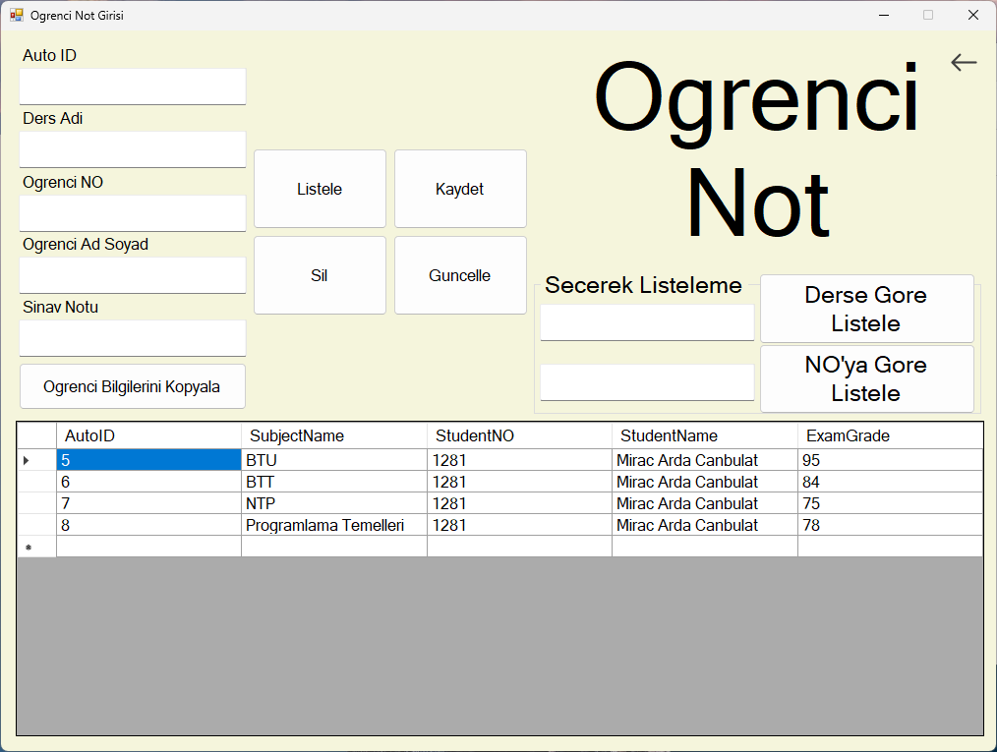
using System;
using System.Collections.Generic;
using System.ComponentModel;
using System.Data;
using System.Data.OleDb;
using System.Drawing;
using System.Linq;
using System.Text;
using System.Threading.Tasks;
using System.Windows.Forms;

namespace OgrenciBilgiSistemi
{
public partial class ogrenciNotGirisi : Form
{
public ogrenciNotGirisi()
{
InitializeComponent();
}

private void backBtnInfo_Click(object sender, EventArgs e)
{
Methods.FormSwitching.FormSwitch(this, new MainPage());
this.Close();
}

private void listeleBtn_Click(object sender, EventArgs e)
{
Methods.DbList.ListDb("subjects", subjectsDBGrid);
}

private async Task giveAlert()
{
System.Media.SystemSounds.Exclamation.Play();
infoCopyBtn.Text = "Kopyalandi";
await Task.Delay(1000);
infoCopyBtn.Text = "Ogrenci Bilgilerini Kopyala";
}
private async void infoCopyBtn_Click(object sender, EventArgs e)
{
if (!string.IsNullOrEmpty(subjectNameEntry.Text) ||
!string.IsNullOrEmpty(studentNOEntry.Text) ||
!string.IsNullOrEmpty(studentNameEntry.Text) ||
!string.IsNullOrEmpty(studentGradeEntry.Text))
{
Clipboard.SetText($"{subjectNameEntry.Text} {studentNOEntry.Text} {studentNameEntry.Text} {studentGradeEntry.Text}");
await giveAlert();
}
else
{
MessageBox.Show("Eksik bilgi oldugu icin kopyalanamadi.", "Bilgilendirme", MessageBoxButtons.OK,
MessageBoxIcon.Information);
}
}

private void subjectsDBGrid_CellContentClick(object sender, DataGridViewCellEventArgs e)
{
int secilen = subjectsDBGrid.SelectedCells[0].RowIndex;
autoIDEntry.Text = subjectsDBGrid.Rows[secilen].Cells[0].Value.ToString();
subjectNameEntry.Text = subjectsDBGrid.Rows[secilen].Cells[1].Value.ToString();
studentNOEntry.Text = subjectsDBGrid.Rows[secilen].Cells[2].Value.ToString();
studentNameEntry.Text = subjectsDBGrid.Rows[secilen].Cells[3].Value.ToString();
studentGradeEntry.Text = subjectsDBGrid.Rows[secilen].Cells[4].Value.ToString();

}

private void ogrenciNotGirisi_Shown(object sender, EventArgs e)
{
Methods.DbList.ListDb("subjects", subjectsDBGrid);
}

private void bySubjectBtn_Click(object sender, EventArgs e)
{
DataTable dataTable = new DataTable();
OleDbDataAdapter dataAdapter = new OleDbDataAdapter($"Select * from Subjects " +
$"WHERE SubjectName={subjectListEntry.Text}",
Variables.DbConn.SubjectsConn);
dataAdapter.Fill(dataTable);
subjectsDBGrid.DataSource = dataTable;
}

private void byNumBtn_Click(object sender, EventArgs e)
{
DataTable dataTable = new DataTable();
OleDbDataAdapter dataAdapter = new OleDbDataAdapter($"Select * from Subjects " +
$"WHERE StudentNO={Convert.ToInt32(numListEntry.Text)}",
Variables.DbConn.SubjectsConn);
dataAdapter.Fill(dataTable);
subjectsDBGrid.DataSource = dataTable;
}

private void kaydetBtn_Click(object sender, EventArgs e)
{
Methods.DbConn.DbConnectionOpen("subjects");
OleDbCommand cmd = new OleDbCommand("INSERT INTO Subjects ([SubjectName], [StudentNO], [StudentName], [ExamGrade]) " +
"VALUES (@p1, @p2, @p3, @p4)", Variables.DbConn.SubjectsConn);
cmd.Parameters.AddWithValue("@p1", subjectNameEntry.Text);
cmd.Parameters.AddWithValue("@p2", Convert.ToInt32(studentNOEntry.Text));
cmd.Parameters.AddWithValue("@p3", studentNameEntry.Text);
cmd.Parameters.AddWithValue("@p4", Convert.ToInt32(studentGradeEntry.Text));
cmd.ExecuteNonQuery();
MessageBox.Show("Basariyla kaydedildi.", "Bilgilendirme", MessageBoxButtons.OK);
Methods.DbConn.DbConnectionClose("subjects");
Methods.DbList.ListDb("subjects", subjectsDBGrid);
}

private void silBtn_Click(object sender, EventArgs e)
{
Methods.DbConn.DbConnectionOpen("subjects");
OleDbCommand cmd = new OleDbCommand("DELETE FROM Subjects WHERE AutoID = ?", Variables.DbConn.SubjectsConn);
cmd.Parameters.AddWithValue("?", Convert.ToInt32(autoIDEntry.Text));
cmd.ExecuteNonQuery();
MessageBox.Show("Basariyla silindi.", "Bilgilendirme", MessageBoxButtons.OK);
Methods.DbConn.DbConnectionClose("subjects");
Methods.DbList.ListDb("subjects", subjectsDBGrid);
}

private void guncelleBtn_Click(object sender, EventArgs e)
{
Methods.DbConn.DbConnectionOpen("subjects");
OleDbCommand cmd = new OleDbCommand("UPDATE Subjects set SubjectName=@p1, StudentNO=@p2, " +
"StudentName=@p3, ExamGrade=@p4", Variables.DbConn.SubjectsConn);
cmd.Parameters.AddWithValue("@p1", subjectNameEntry.Text);
cmd.Parameters.AddWithValue("@p2", Convert.ToInt32(studentNOEntry.Text));
cmd.Parameters.AddWithValue("@p3", studentNameEntry.Text);
cmd.Parameters.AddWithValue("@p4", Convert.ToInt32(studentGradeEntry.Text));
cmd.ExecuteNonQuery();
MessageBox.Show("Basariyla guncellendi.", "Bilgilendirme", MessageBoxButtons.OK);
Methods.DbConn.DbConnectionClose("subjects");
Methods.DbList.ListDb("subjects", subjectsDBGrid);
}
}
}

